Kids Plus™ Accident Insurance
For your convenience, we’ve made arrangements for families to voluntarily purchase student accident insurance through the Kids Plus™ Accident Insurance program, underwritten by Industrial Alliance Insurance and Financial Services Inc (iA Financial Group).

Kids Plus™ Accident Insurance offers protection against the unexpected costs of injury from accidents, and is especially valuable for families who:
- do not have medical or dental plans,
- have limited plans, as it may help supplement health and dental benefits, or
- have active children who enjoy sports and outdoor activities.

For complete plan details, please visit kidsplus.ca.

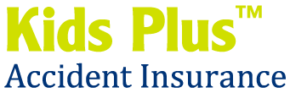
iA Financial Group is a business name and trademark of
Industrial Alliance Insurance and Financial Services Inc.

